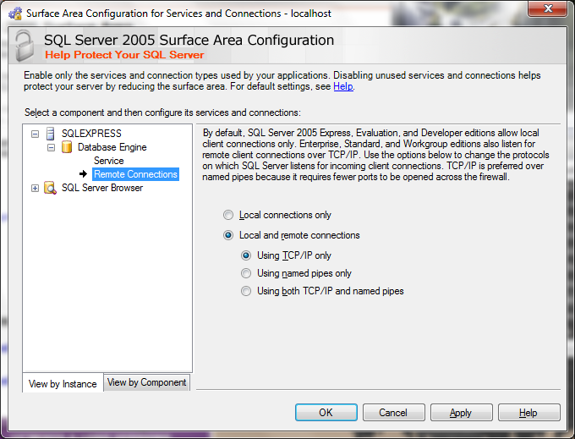

Allow remote connection for SQL Server.